Maths
The children will learn to…
Link numerals and amounts, showing the right number of fingers or objects to match numerals up to five.
Ordering the numbers
Making numbers in different ways up to five
Matching number with quantities

Reading
The children will have the opportunity to explore map and learn where most of the safari animals are coming from.

Recognise familiar words and signs, such as their own name and advertising signs

Count or clap syllables in a word

Recognise words that start with the same initial sound.

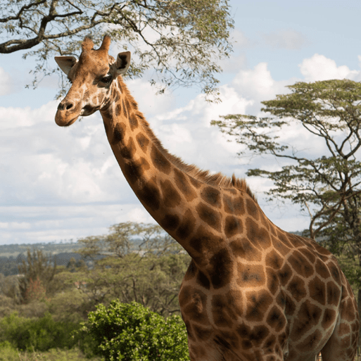

Summer term 2026
Saplings Class
THEME: Safari animal

Personal, social and emotional development
Begin to talk about why it is important to wear a hat and sunscreen on sunny day
Care for the plants and the animals in the surrounding environment
Follow instructions when in different environments and when handling simple equipment
.

Communication and Language

Begin to use recently introduced vocabulary to talk about the principal characters in stories
Engage in extended conversations about stories and, with support, make links to other familiar stories.
Begin to use recently introduced vocabulary to talk about the principal characters in stories.

Writing
Drawing pictures of their friends and tracing/copying their names.

The children will be making their own sea side pictures and label them.

Fine Motor Skills
Developing scissor skills Using straight lines and shapes cutting

Making playdough and play dough disco

Mark making with big circular movements

Understanding the world

Begin to observe and talk about living things in the local environment.

Care for growing seeds and plants and describe observable features of different types of plants and trees

Gross Motor Skills
Use a range of media, tools and techniques to create images, express ideas and show different emotions.

Join in with games that include racing, chasing, balancing, riding (scooters, trikes and bikes) and ball skills.

Large movements using parachute.
Use scissors, painting and playdough develop fine motor skills

Trips/visits/visitors/key diary dates
Forest school, Sports Day, water fun day, end of year picnic

Expressive Arts and design
.

Explore ways of changing the shape or texture of malleable materials.

Learn and sing songs and rhymes

Listen with increased attention to sounds

