Maths
The children will learn to…
Count to 5 forwards and backwards using objects such as seeds.
Play games such as hide and seek to learn positional language.
Linking numerals and amounts using natural resources.
Begin to explore one more and one less using objects.
Notice and correct errors in patterns and create their own simple patterns whilst making fruit kebab caterpillars.

Reading

The children will have the opportunity to explore the story The Very Hungry Caterpillar through exciting Talk for writing sessions and fun filled activities in the provision.
They will then have the opportunity to perform the story using a story map to the class.

The children will have the opportunity to engage in sound games and begin to say the initial sounds in words such as their name.

The children will have the opportunity to engage in conversations about stories and explore the meaning of new words such as cocoon, bouquet and antennae.

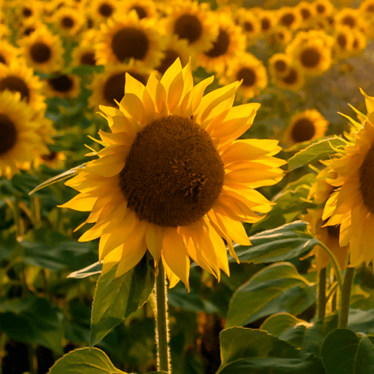

Summer term 2026
Saplings Class
THEME: Sunshine and Sunflowers

Communication and Language

The children will learn new words associated with growing, plants and insects and begin to use these words when describing or explaining what they know through play.

The children will be participating in circle times and group discussions to express their ideas and feelings. They will be encouraged t give good proof of listening to their friends and turn take during conversations.

Personal, social and emotional development

The children will explore healthy food choices and the need for exercise through the story ‘The Very Hungry Caterpillar.’
Learn about sun safety-wearing hats and sun cream.
Begin to understand how others may be feeling, talking about friendships and what makes a good friend.

Writing
Children will have the opportunity to write their names daily, participate in RWI letter writing sessions and create their own story maps.

Fine Motor Skills
The children will use a range of small tools, including scissors and paint brushes to create playdough models and cut a variety of fruits and herbs in the mud kitchen.
They will learn how to develop their pencil grip through butterfly drawings of maps of the school.

Gross Motor Skills
This half term the children will explore Athletics in their weekly PE sessions
Using PE sessions to become more independent with dressing themselves.
Understanding the world

To care for growing seeds and plants that they have planted and observe the changes that they see. They will learn the names of parts of a plant such as the stem and the roots. They will look at the life cycle of a butterfly through stories and games.
The children will learn about habitats and that they are a place where living things live through forest school exploration and stories.
Expressive Arts and design

The children will learn to explore colour and application of paint using a range of different tools through Butterfly symmetry pictures.
Use a range of media, tools and techniques to create images, express ideas and show different emotions creating their own sky gardens and bee hive pictures.
The children will create their own nursery rhymes with support from an adult and perform them to the class.

Trips/visits/visitors/key diary dates
Forest school Stay in and play session

